HNDIT4242 – Enterprise Architecture

Lab sheet 02

1)

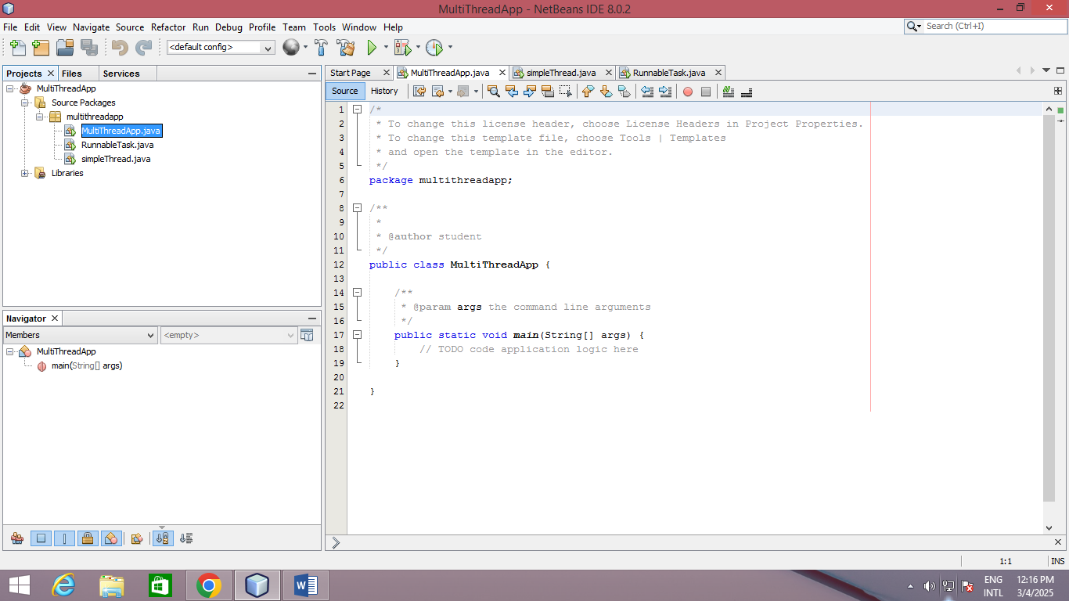create Multi Thread app

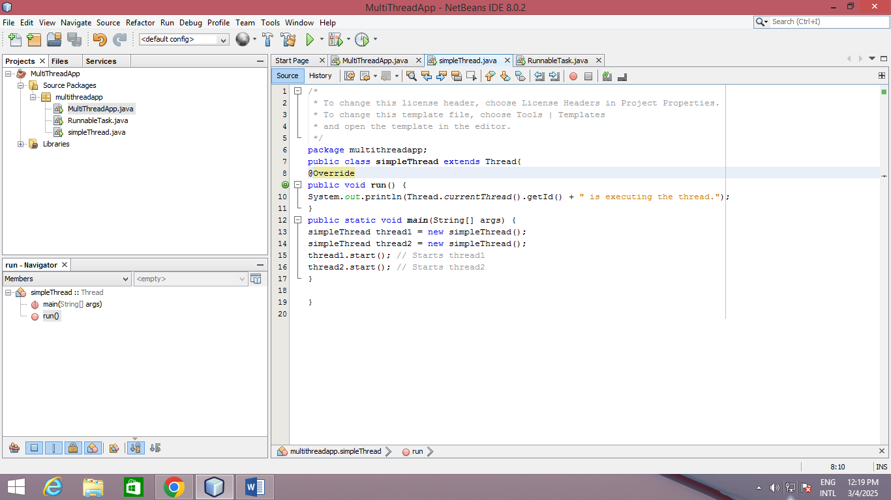create a new class Simple Thread

Output –

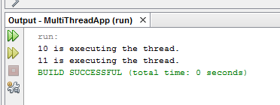

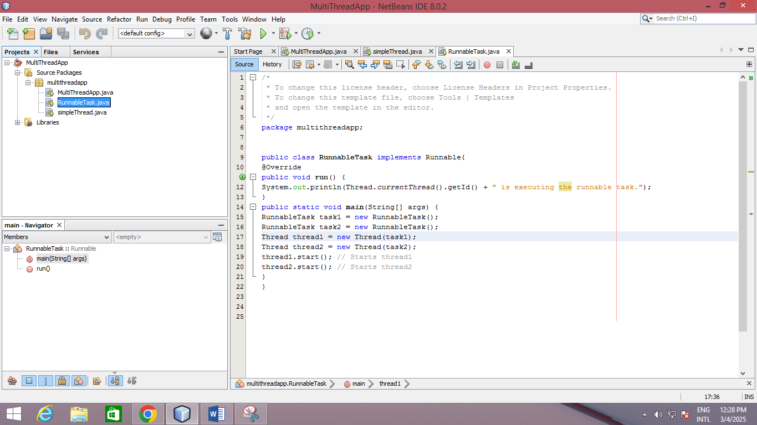2) Create a Runnable Class

Output –



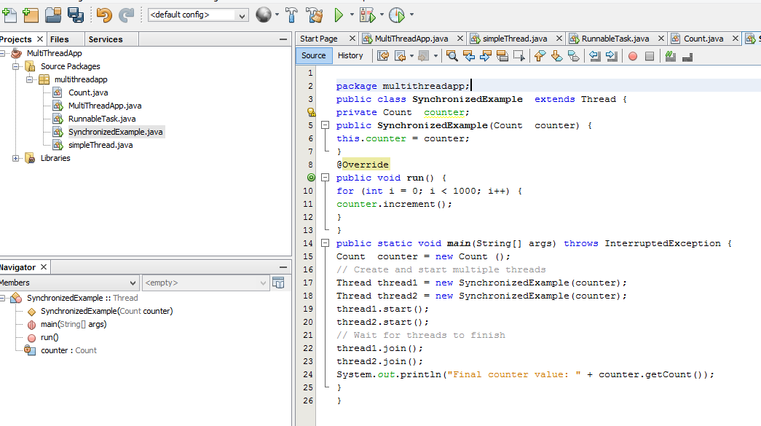3) Create a new class called Counter.java to demonstrate synchronization with shared resources.

Output-

